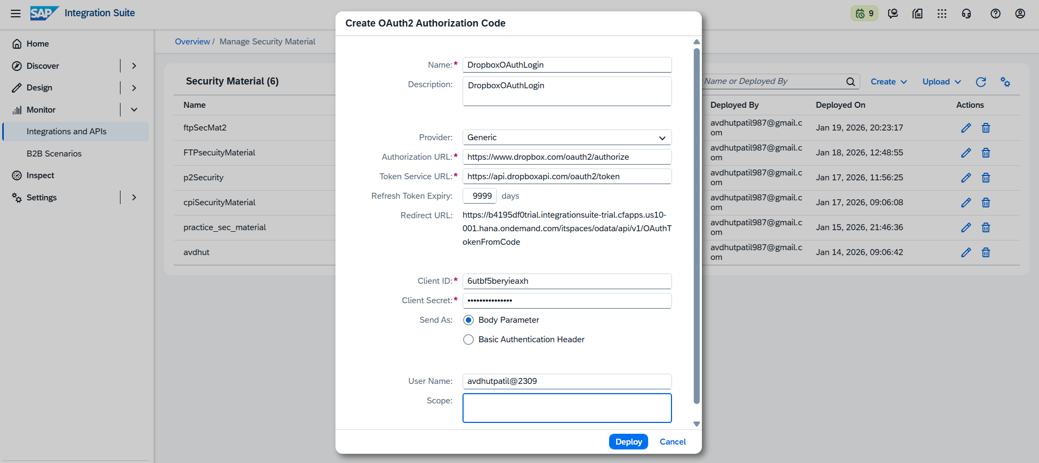
🔹 2. Authorization URL (MOST IMPORTANT)
📍 You will NOT see this as a field in Dropbox UI
This is a fixed Dropbox OAuth endpoint.
👉 Use this in SAP CPI:
https://www.dropbox.com/oauth2/authorize
✔ This URL is official Dropbox OAuth Authorization endpoint

🔹 3. Token Service URL
📍 Also not shown as a field in Dropbox UI
This is another fixed endpoint.
👉 Use this:
https://api.dropboxapi.com/oauth2/token

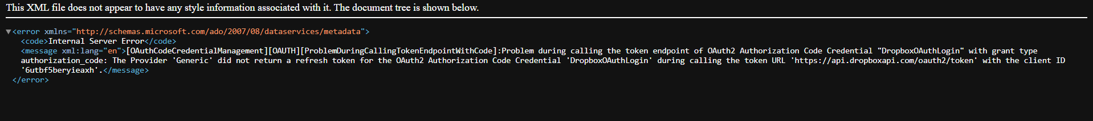
Checked urls again and its working
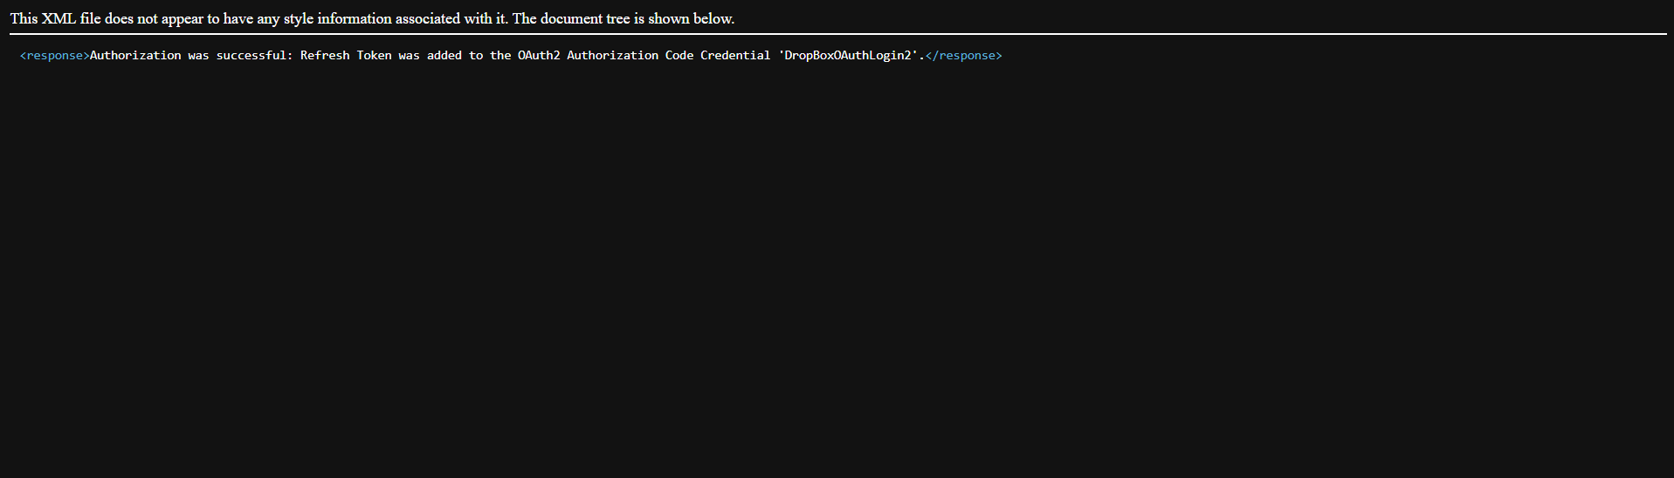

🔹 SMTP vs IMAP – Core Difference
Feature | SMTP | IMAP
Full form | Simple Mail Transfer Protocol | Internet Message Access Protocol
Purpose | Send emails | Receive & read emails
Direction | Outgoing | Incoming
Message storage | Does not store emails | Emails stay on server
Used when | Sending mail | Reading / polling inbox

🔹 Functional Difference (Easy to Remember)
- SMTP → Push email 📤
- IMAP → Pull email 📥

🔹 Port Numbers (Very Important)
Protocol | Server Example | Port | Security
SMTP | smtp.gmail.com | 465 | SSL
SMTP | smtp.gmail.com | 587 | STARTTLS
IMAP | imap.gmail.com | 993 | SSL

🔹 Data Handling Difference
SMTP
- Sends email to recipient server
- No inbox access
- No synchronization
- One-way communication
IMAP
- Reads email directly from server
- Syncs across devices
- Supports folders (Inbox, Sent, etc.)
- Emails remain on server

🔹 Use in SAP CPI
Scenario | Protocol
Send alert / notification | SMTP
Read incoming emails | IMAP
Poll mailbox for attachments | IMAP
Error notification | SMTP

🔹 Authentication (Modern Systems)
- Username + App Password
- OAuth2 (in advanced setups)
- SSL/TLS mandatory

🔹 Common Interview Question
Q: Can SMTP receive emails?
❌ No. SMTP is only for sending.
Q: Can IMAP send emails?
❌ No. IMAP is only for reading.

🔹 One-Line Memory Trick
SMTP = Send Mail Transfer Protocol
IMAP = Inbox Message Access Protocol

🧠 Interview-Ready Statement
“SMTP is used for sending emails, while IMAP is used to retrieve and synchronize emails from the mail server. In SAP CPI, SMTP is used for notifications and IMAP for inbound mail processing.”

